



**Chart Components**

**Description:** Following are the common chart components which are implemented using d3.js.

**Requirement:**

* Install d3.js using following command:

npm install d3

* Make sure d3 component entry has been added in “app.module.ts”
* Import d3 in component where you have to implement any chart using d3

1. **Line Chart Component:**

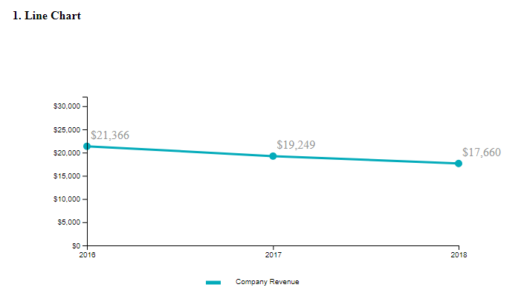

* We can define chart properties like font size, theme, label font, legend properties, line thickness etc. in one object and pass it to the line chart component from html by passing name of object to chartData property.
* We can set height, width etc to svg using d3.select().append()
* **Sample Data Object:**

this.lineChartData = [

{label: "Current Year Company Revenue", value: "17659.679"},

{label: "Company Revenue Prior Year 1 (Mean)", value: "19249.051"},

{label: "Company Revenue Prior Year 2 (Mean)", value: "21366.446"}

]

**Html example: <line-chart [chartData]="** **lineChartProperties** **" id="cioLineChart1" chartId="cioLineChart1"></line-chart>**

**Property Object:**

this.lineChartProperties = {

chart: {

animation: false,

smartLineAlpha: "100",

showlegend: "1",

labelFont: "OpenSansRegular",

labelFontSize: 16,

legendItemFontSize: 16,

showToolTip: false,

legendposition: "bottom",

usedataplotcolorforlabels: "0",

showTooltip: "1",

theme: "fint",

lineThickness: "3",

formatNumberScale: 0,

anchorBgColor: "#03abba",

showHoverEffect: 0, // disable zoom on mouse over

interactiveLegend: 0, // disable hide of line

divLineDashed: 0, // change chart background dot line to stright line

legendItemFontColor: "#75787b",

palettecolors: "#03abba",

numberprefix: "$"

},

categories: [{

category: [{

label: "2016"

},

{

label: "2017"

},

{

label: "2018"

}

]

}],

dataset: [{

seriesname: "Company Revenue",

"data": this.lineChartData // You can create data object and pass it here

}]

};

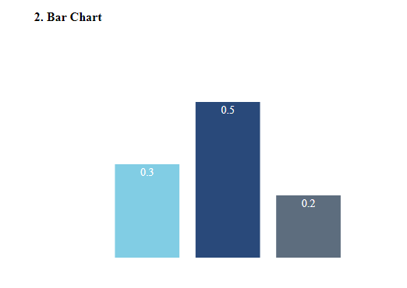

* We can set chart properties like height, width, margin using:

d3.select("#"+chartId)

.append("svg").attr("width", "200%")

.style("margin-top","100px")

* **Html Example:**

<app-barchart id="incidenceResponse" chartHeight="200" chartID="incidenceResponse" [chartData]="[ '', this.barChartData.P1.value | number : '1.1-1', this.barChartData.P2.value | number : '1.1-1',this.barChartData.P3.value | number : '1.1-1', '']"></app-barchart>

* **Sample Data Object:**

this.barChartData = {

"P1": {"key":"workplace_services_p1","value":"0.33"},

"P2": {"key":"workplace_services_p1","value":"0.45"},

"P3": {"key":"workplace_services_p1","value":"0.24"}

}

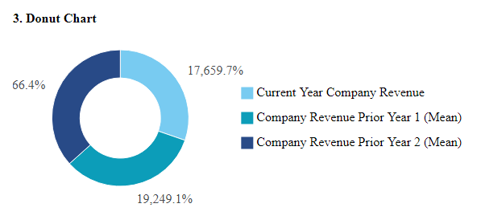

* **Html Example:**

<drill-down-donut-chart id="itMgmt-drillDown" chartID="itMgmt-drillDown" [chartData]="donutChartData"

thickness="35" chartWidth="180" chartHeight="230"></drill-down-donut-chart>

* We can set chart properties like height, width, margin using:

d3.select("#"+chartId)

.append("svg").attr("width", "200%")

.style("margin-top","100px")

* **Sample Data Object:**

this.donutChartData = [

{label: "Current Year Company Revenue", value: "17659.679"},

{label: "Company Revenue Prior Year 1 (Mean)", value: "19249.051"},

{label: "Company Revenue Prior Year 2 (Mean)", value: "21366.446"}

]

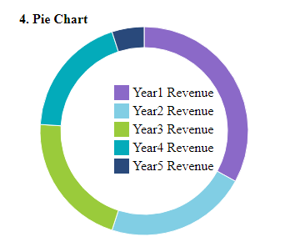

* **Sample Data Object:**

drillDowndata = [

{label: "Year1 Revenue", value: "33"},

{label: " Year2 Revenue ", value: "22"},

{label: " Year3 Revenue ", value: "21"},

{label: " Year4 Revenue ", value: "19"},

{label: " Year5 Revenue ", value: "5"}

]

* **Html Example:**

<pie-chart id="cioPersonnel" chartID="cioPersonnel" chartWidth="105" chartHeight="105" thickness="10.5"></pie-chart>

* We can set inner, outer radius, height width using following:

1. d3.select('#'+this.chartID).append('svg').attr('width', width).attr('height', height)

.append('g').attr('transform', `translate(${width / 2}, ${height / 2})`)

1. d3.arc().innerRadius(totalRadius - donutHoleRadius).outerRadius(totalRadius)

**5. Generate PDF:**

1. Install JSPDF using:

npm install jspdf –save

1. Install JSPDF-autotable:

npm install jspdf-autotable

1. Add following in "angular.json” :

Scripts: [

“node_modules/jspdf/dist/jspdf.min.js”,

“node_modules/jspdf-autotable/dist/jspdf.plugin.autotable.min.js"

]

1. Import it in your component:
   * + import * as jsPDF from ‘jspdf’
     + import 'jspdf-autotable'